
Renee Murphy Legacy Scholarship - High School Senior Application
Application deadline: Friday, April 17, 2026
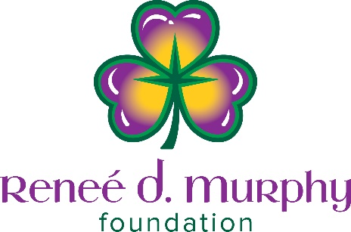

Send application postmarked or emailed by deadline to:
Ankeny Area Chamber of Commerce 1360 SW Park Square Dr., Ste. 106, Ankeny, IA 50023
OR Email to: info@ankeny.org. Phone number for questions: (515) 964-0685
Name of Applicant:
Cell Phone:
Home Mailing Address:
Email address of applicant:

High School:
High School Address:
High School Counselor:
Counselor’s Email Address:

Father’s Name:
Father’s Email:
Father’s Home Address:

Mother’s Name:
Mother’s Email:
Mother’s Home Address:
Stepparent or Guardian other than your parents – list name(s), home address(es) and email(s):

List in chronological order the names of your brothers, sisters, or other person’s dependent upon your parents for support:

College, University, Vocational School, or Volunteer/Civic Minded Project:
Institution Name:
Institution Address:
Planned Areas of Study:
If you don’t plan to go this route, what would you use the scholarship for? (Ex. AmeriCorps/housing for volunteer or mission trip/civic minded project, etc.)

Renee Murphy Legacy Scholarship
Renee Murphy was an engaged, civic-minded citizen as well as an integral part of the Ankeny business community. The Ankeny Area Chamber of Commerce is honored to be the administrator for the Renee Murphy Legacy Scholarship which will be given to three Ankeny graduates. Three scholarships of $1,000 each for Ankeny High School, Ankeny Centennial High School, and Ankeny Christian Academy. We reserve the right to give more than one candidate at a high school a scholarship if there is not a qualified candidate or to a better candidate from a non-qualifying high school.

The Renee Murphy Legacy Scholarship will reward civic and community involvement, volunteerism, and celebrate Renee’s life-long passion for helping others. Given to a senior who is serving on a civic oriented organization (example: Mayor’s Youth Council, student school board, Sons or Daughters of the American Revolution, student council, Polk County Conservation Youth Corps, National Honor Society, 4-H Teen Council in Polk County, American Legion Boys or Girls State, Iowa Youth Congress, etc.), preferably in a leadership role (chair, President, VP, etc.).
The scholarships are presented at Senior Night at each of the high schools.

1. Civic Leadership Activities: (List Activity, Grade, Leadership Position, Dates When Held)
List the high school civic activities in which you have participated. After each activity, indicate the grade(s) in which you participated by using the symbol 9, 10, 11, 12. Then list any leadership positions you may have held in this activity and indicate the grade (9, 10, 11, 12) when the position was held. (Attach additional sheets if necessary)

Why did you choose these activities and what did you gain from your participation?

2. Community Service: (List Area of Service, Leadership Position, Dates When Held)
Describe the ways in which you, as a volunteer, have been of service to your community. Indicate any leadership roles you may have had in this area. (Attached additional sheets if necessary)

Why did you choose these activities and what did you gain from the experience?

(Please Attach Any Supporting Documents, Resumes, etc.)

